**EC2 (Elastic cloud Compute) instance**

1. It allows to launch our own virtual machines in AWS

AMI – Amazon Machine Image

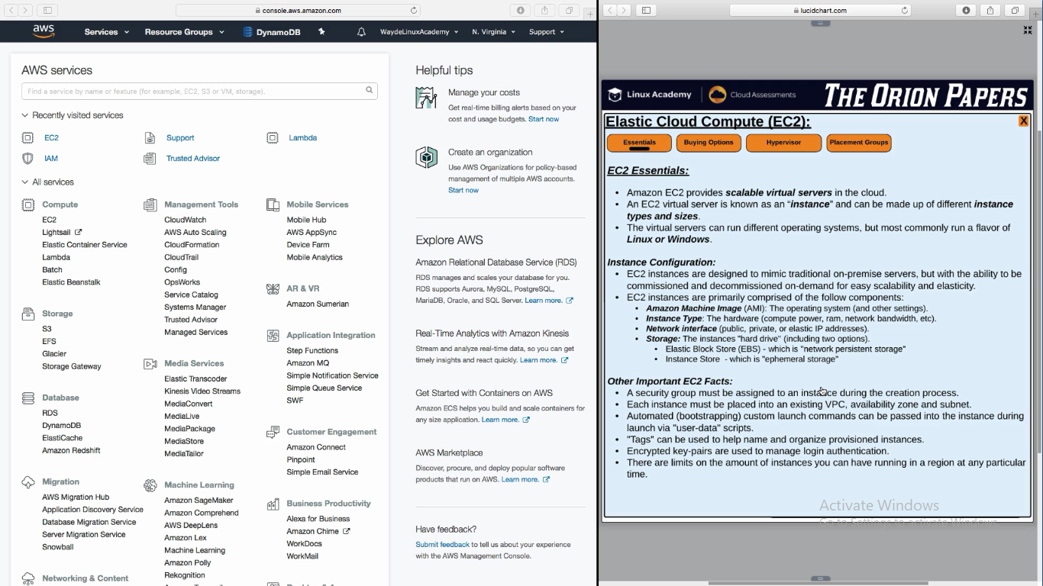

**Storage:**

EBS – Elastic Block Storage - It allows to allocate a storage to our EC2 Instance

Instance Storage – Local on the EC2 Instance

At least one security group is needed for each EC2 Instance

BootStrap – Script which needs to be started when EC2 instance starts. We can write a script

Tag – Tag a VM Instance for organizing AWS resource (by project, organization unit)

**Key-pair used to login to the VM Instance**

It have public and private key

Amazon copied the public keep to the VM instance when it is crated

We have to give the private key when we login to a VM instance

**Limit** - How much EC instance we can run

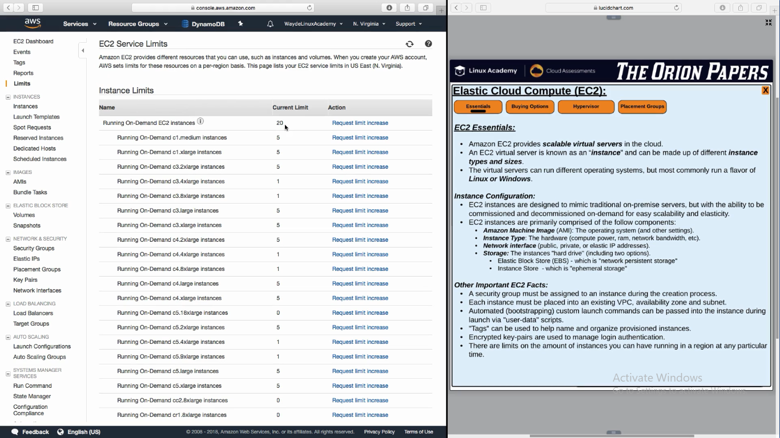

**HyperVisor**

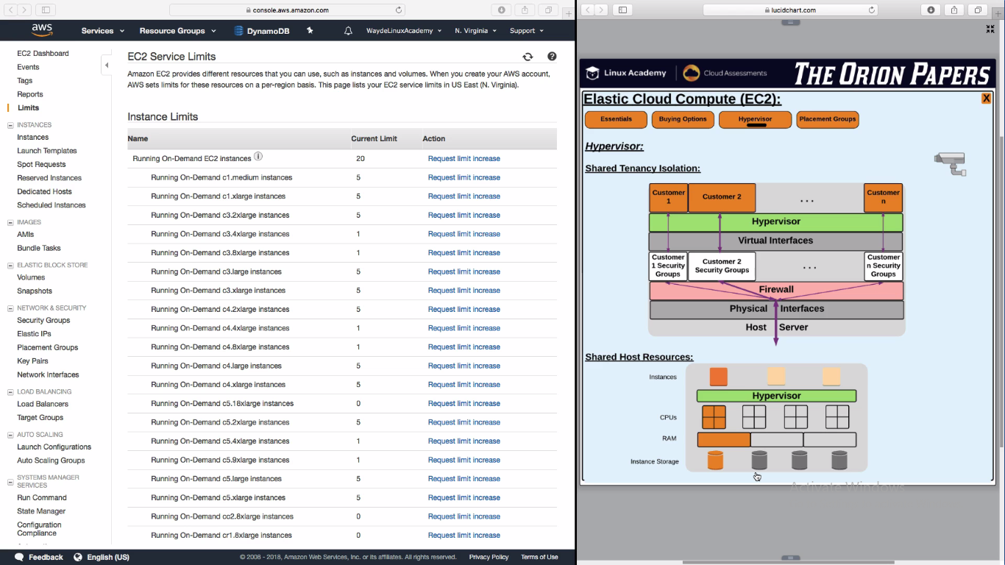

Logging to a EC2 instance is with a key pair. One part is public key and it is copied to EC2 instance

We have to give the private key and login to the EC2 instance

AMI – Amazon Machine Image

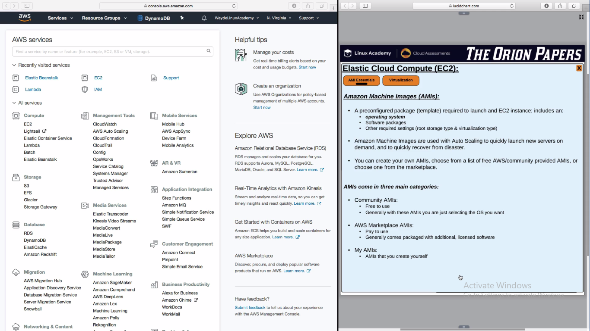

EC2 AMI Instance Features cannot be changed

1. **Root Device Type** : EBS
   1. Elastic Block Storage
2. **Virtualization Type** : HVM

**Types of Virtualization:**

**HVM AMI**– Hardware Virtual Machine

This is preferred as it gives access to underlying hardware extensions

It has all features that PV have through a PV driver

**PV AMI** – ParaVirtual

It cannot use the hardware extensions like enhanced networking or GPU processnig

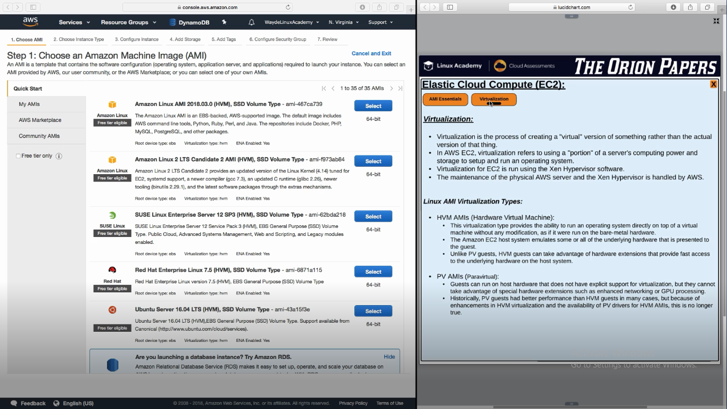

**Selecting an EC2 AMI**

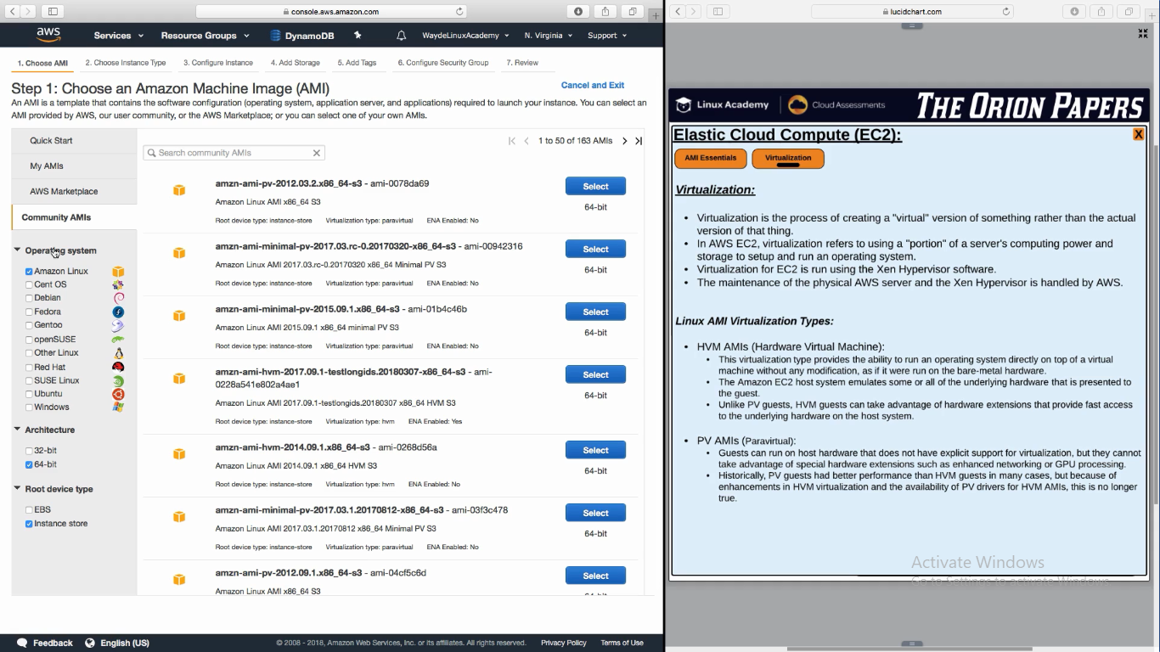

**Choosing Correct AMI Instance type:**

AWS uses inter core process for all host servers

HPC – High Process Compute

**PROCESSOR Types:**

**AVX** – High work load

**AES-NI** – to encrypt/decrypt storage files or db files

**Turbo bost** – when process run in higher clock speed – Controlled by temperature of process

**TSX** – Executing threads in parallel independently

**P state and C state Control** – Optimizing the process we want

Smallest processor is nano. Largest processor is 32 Extra large

Each size we move up, it is double the size and double the cost

**M** – General purpose - ex – mid size DB

**M5** – General purpose 5th generation Machine

**C** – Compute optimized instance – Ex – performing Analytics

**H1** – Storage optimized – It has a local hard disk storage on host machine

**R** - More memory consuming app. R gives more RAM

**X** – More ram RAM +High IOPS SSD Storage - Expensive

**G, P** – We get GPU alone with RAM and SSD (Graphics Processing Unit – used for gaming and graphics apps)

**F** – We create our own code for hardware acceleration. Our custom app will take advange of this acceleration

**T** – All above have a dedicated CPU. This T does not have a dedicated CPU. It works on a credit based mechanism.

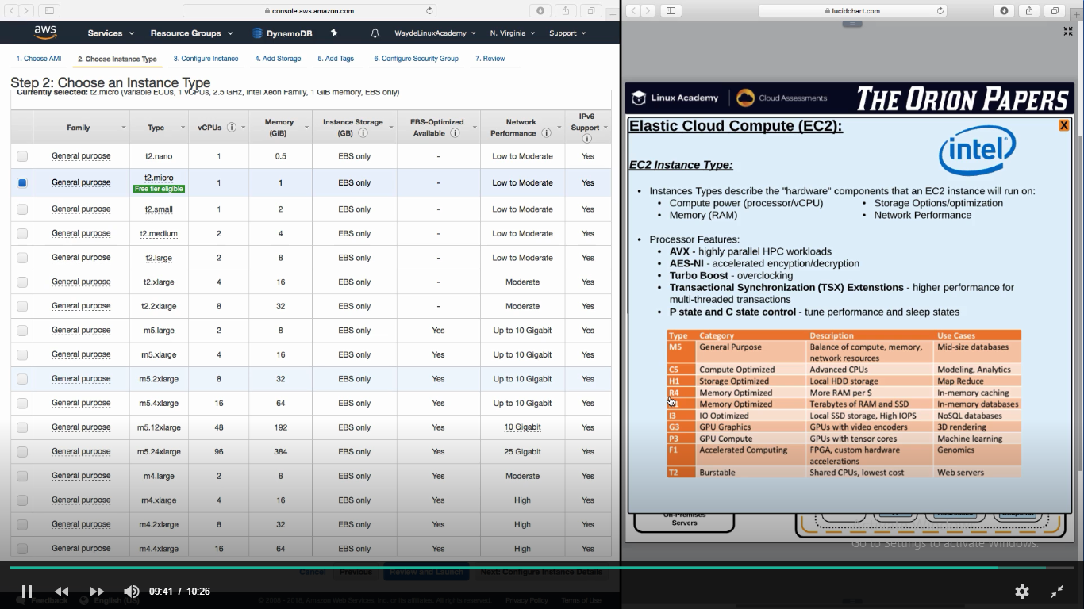

**EC2 IP Address**

EIP – Elastic IP Address

Elastic Ip addresses are constant. They are public ips

If we do not assign a public ip to the instance while creating, latter we can do it via EIP

If we terminate a EC2 instance which have an elastic IP Address, this address will be release and will be goes back to the account. We can associate it to another EC2 instance.

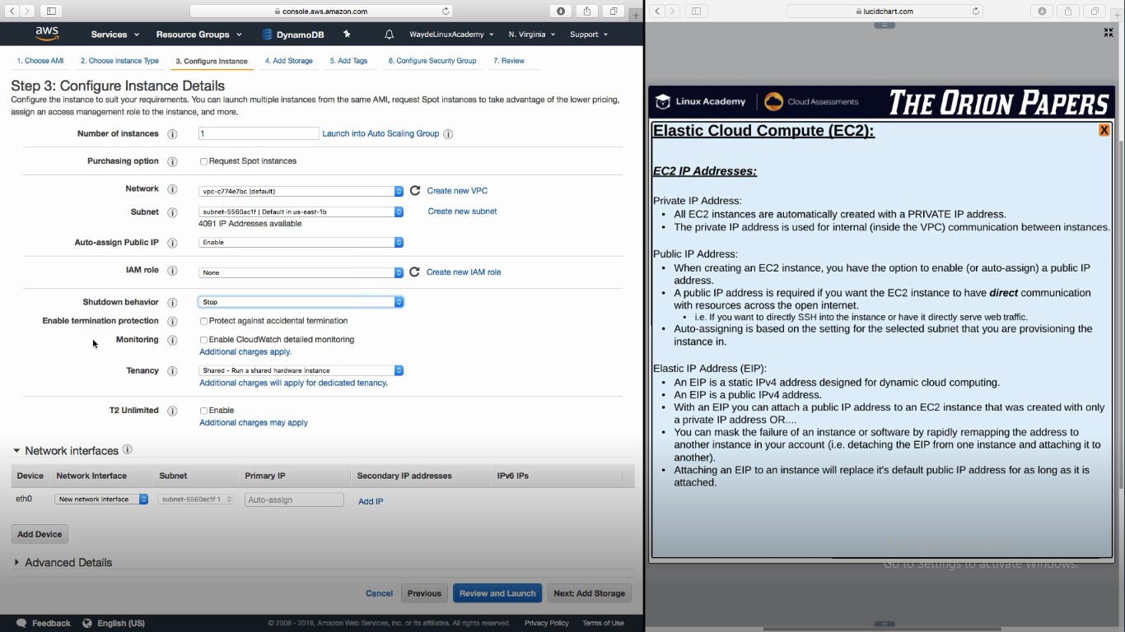

BootStrapping:

Advanced details is the bootstrapping 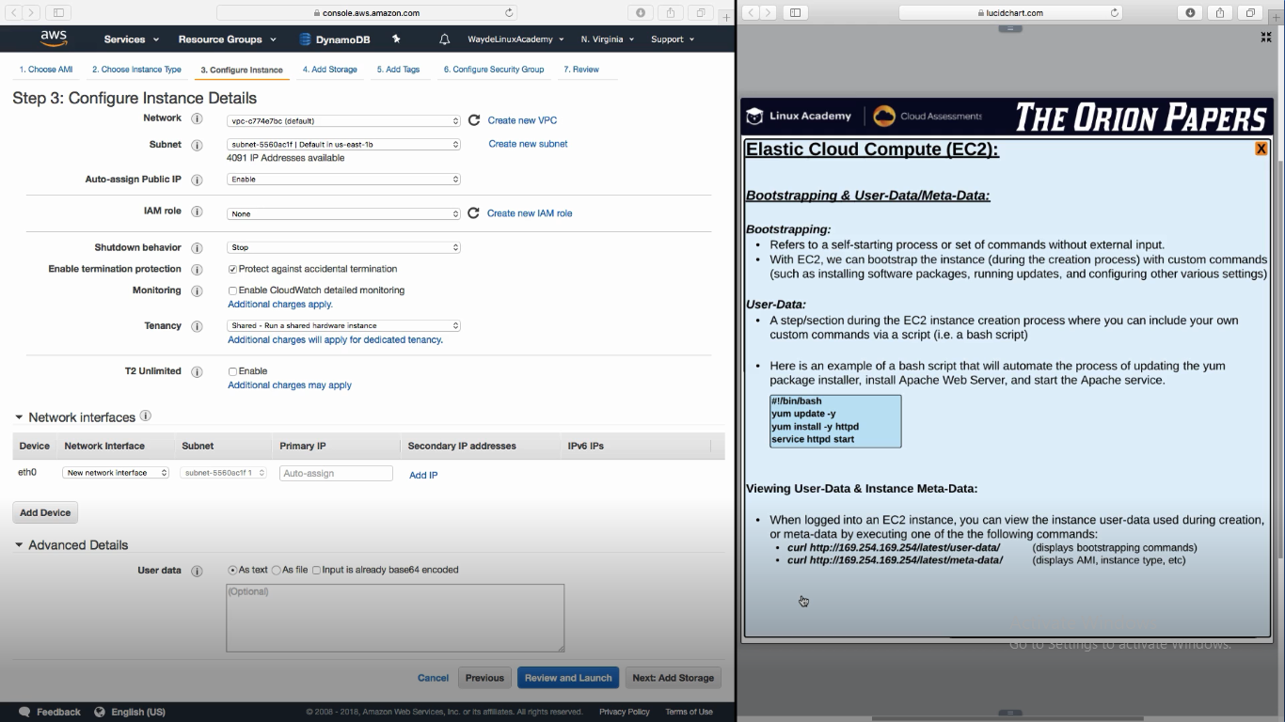

Monitoring Metrics – Every one minute interval if selected

T2 unlimited –

If CPU is used below the threshold, we gain credit. This credit will be used when CPU utilization goes above limit. When the limit is over, AWS will set the CPU to its default state which affects the application. If this option is selected, CPU will not go to the assigned limit. But we have to pay for choosing unlimited

**Network Interface:**

EC2 instance on multiple networks in multiple subnets is possible by adding an another Ethernet device in network interface

If this instance is not good and we want to terminate this ec2 instance and assign this public ip to another ec2 instance, detach the eth from this ec2 instance and attach it to the other instance

**EC2 Storage**

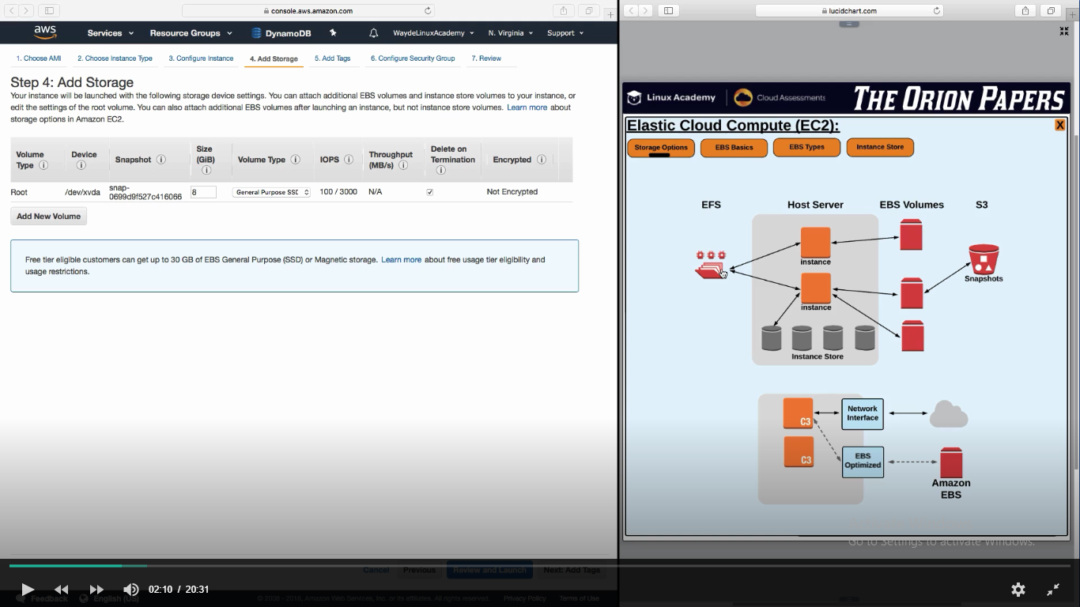

EBS – Elastic Block Storage

1. It can be mapped to only one EC2 instance
2. One EC2 instance can have multiple EBS volumes mapped to it
3. It is outside the host machine and can be accessed by network
4. This cannot be used as boot volume. It can be used for application/data
5. If we stop the EBS instances, data’s in EBS are still alive and can be used when we start the EC2 instance back
6. But EBS is lost when we terminate the EC2 instance. But this option can be changed
7. This can be backedup as objects in S3. This is called snapshots
8. 99.99% available. It has two hardware device which are in sync. When one is down the other will up and serve the data. So data’s are persistent

IOPS – Input output Performance

**Restoring snapshot from S3**

1. Restore a snapshot and add it to a EBS
2. It will happen quickly how big the total size it
3. Files will not be available unless it is needed. It is a lazy load mechanism
4. More the files we read, more the speed we get
5. We have to write a script which reads all files and make the blocks available
6. Data’s are stored in block in EBS

**EFS – Elastic File System**

1. It can be mapped to multiple instances
2. It is outside the host machine and can be accessed by network
3. This cannot be used as boot volume. It can be used for application/data
4. Datas in EFS are permanent

**Types of EBS**

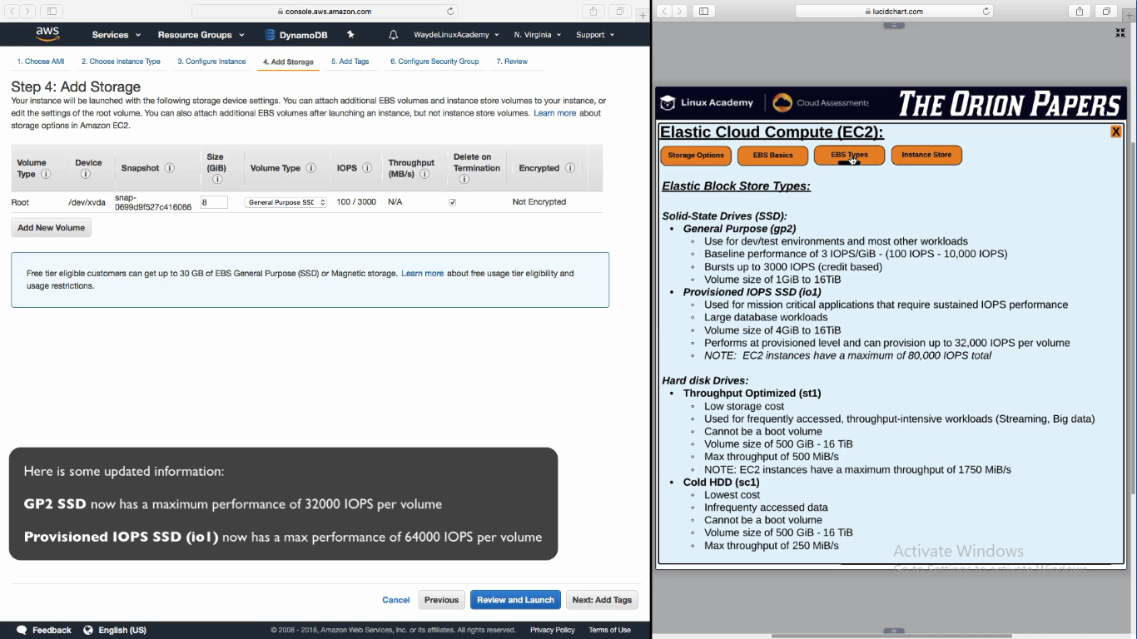

Harddisk cannot be used for boot

**Instance Store**

1. This storage is inside the host server itself
2. These are local volumes on the host machine
3. It can be used for boot volume and other application related data’s
4. Data’s are removed when the instance is stopped

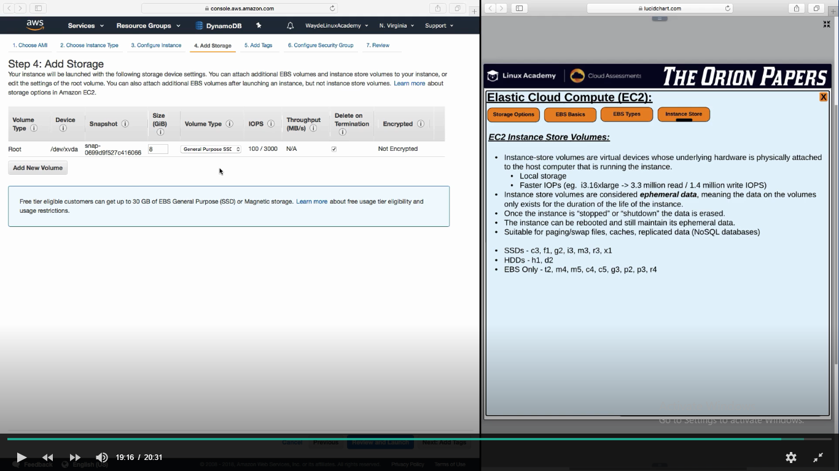

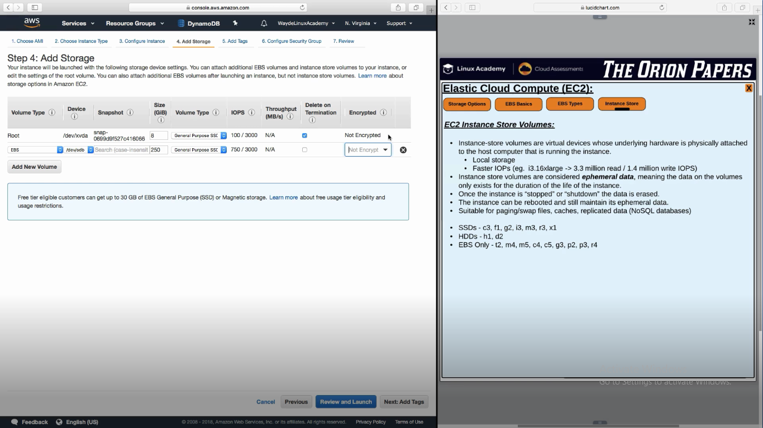

**Adding tag to an Instance**

An instance can have max of 50 tags

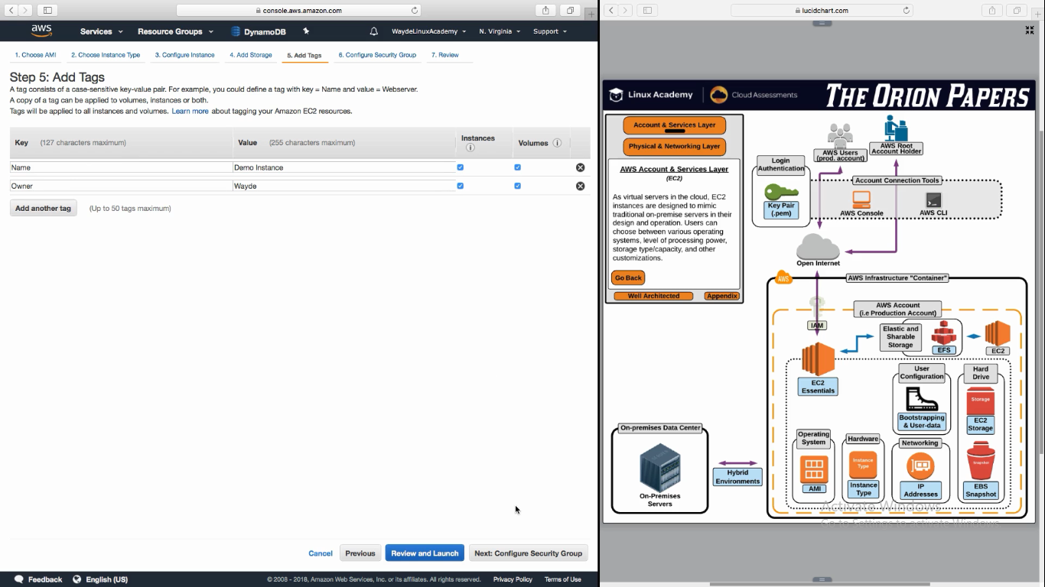

**Security Group**

Each EC2 instance should have atleast one security group. It describes what input connections to be processed

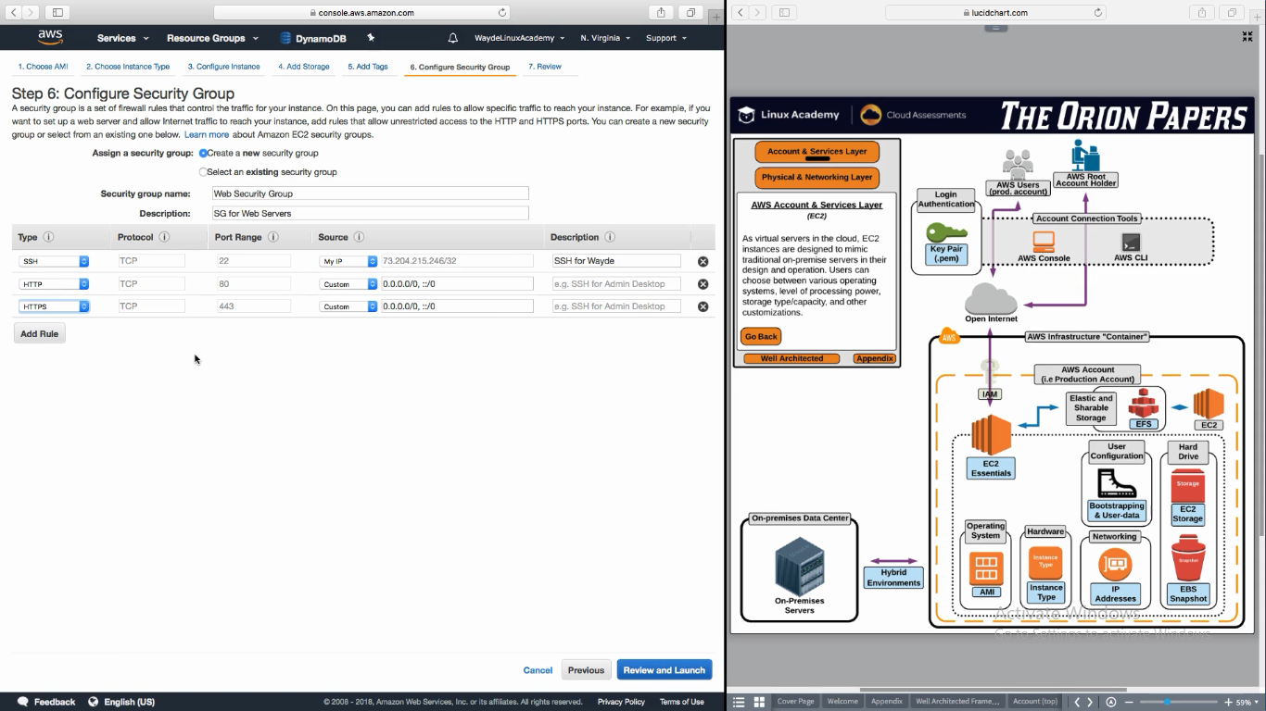

**Create a Key pair**

Create a key paid and download it. It will give the private part of the key. It will be saved on the instance automatically. When we give launch the EC2 instance, it will copy the public part of the key to the instance

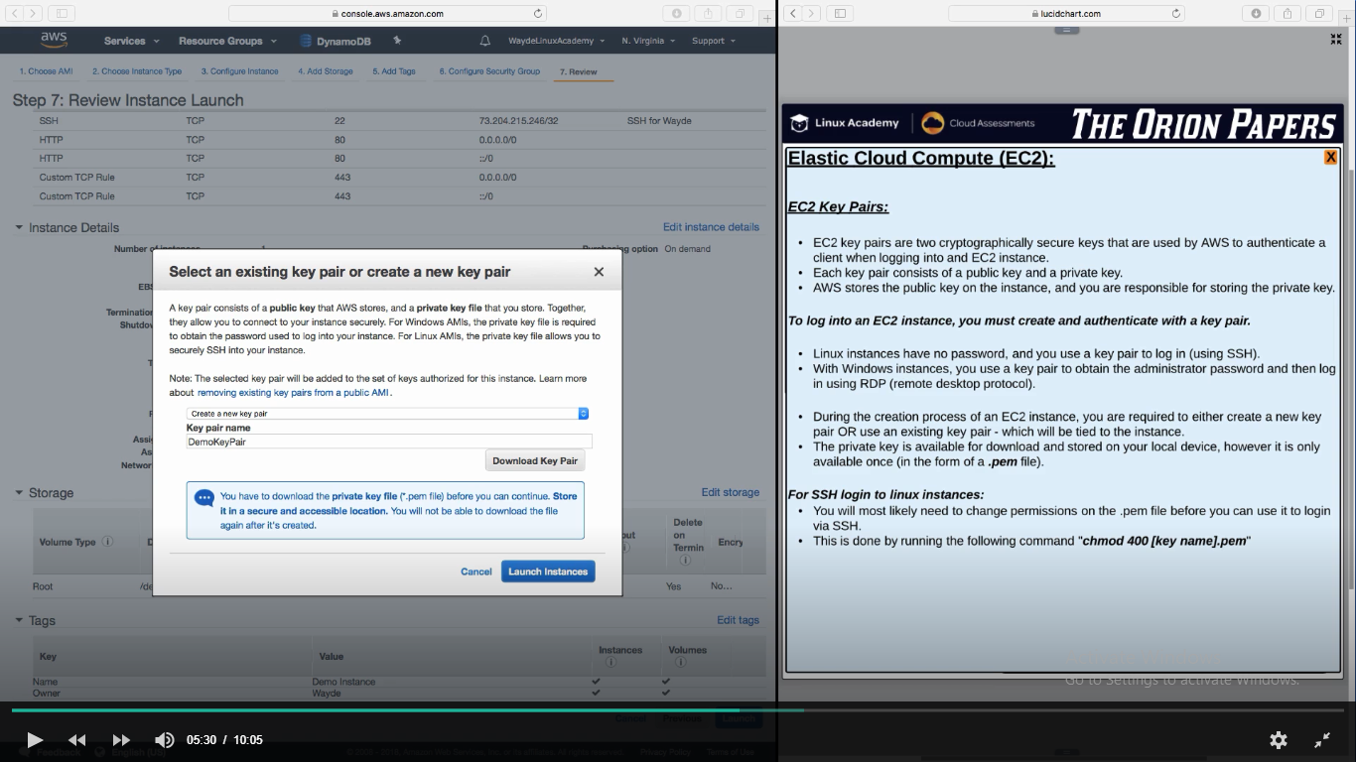

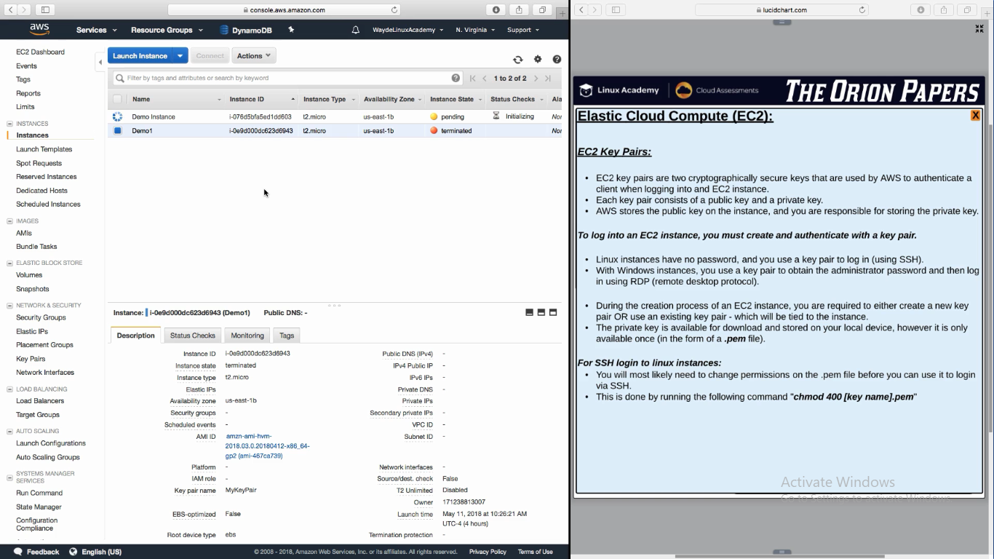

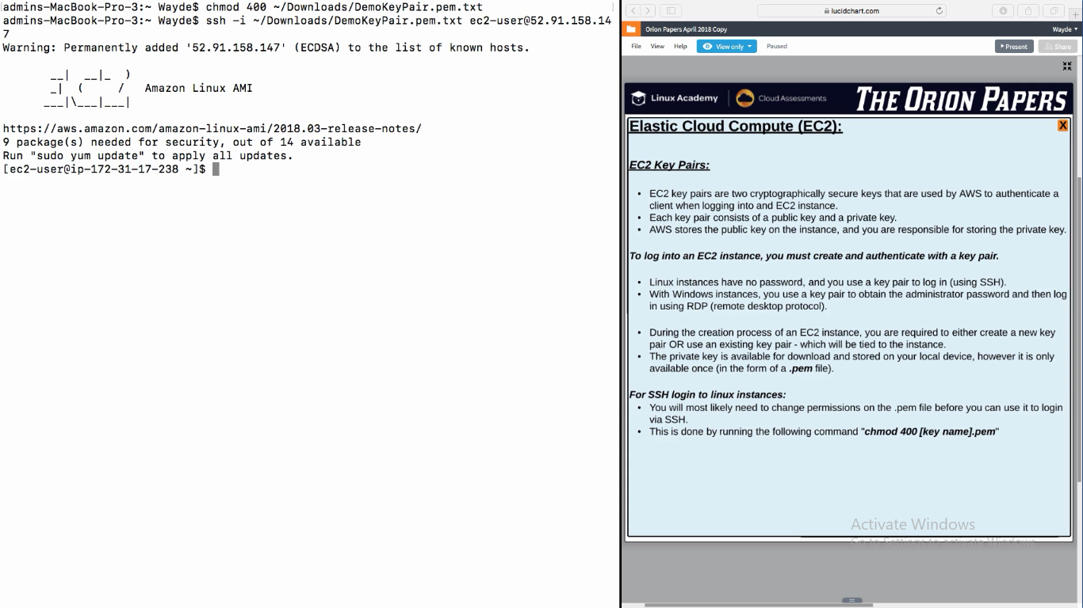

**EBS Snapshots**

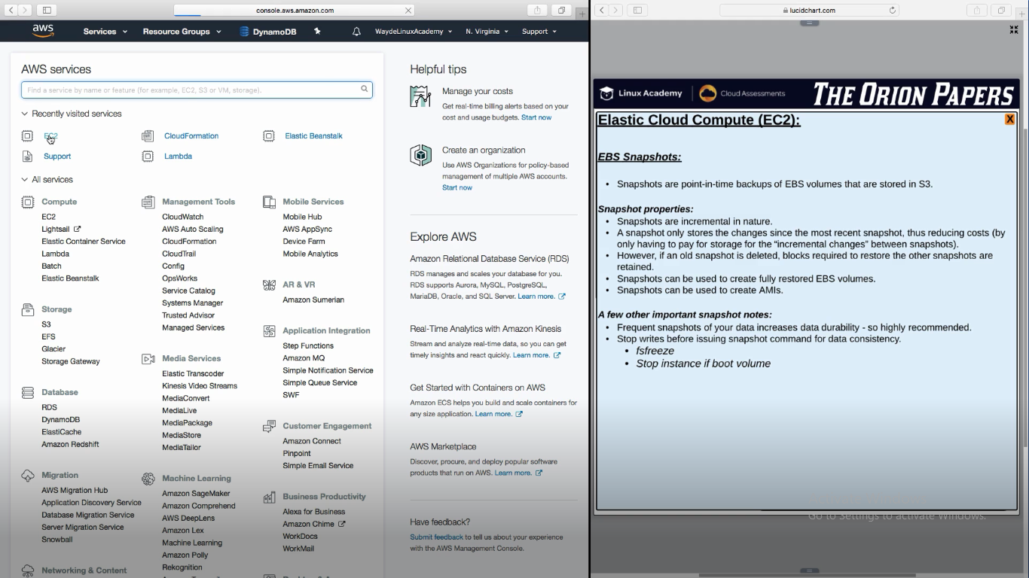

With snapshot I can create an AMI

Volumes -> Snapshot -> Image

Volumes -> snapshot -> Volumes

**EC2 Placement**

It is a request to AWS for placing the EC2 instance in cluster (as close as possible to gain good throughput)

It is free

It helps in inter node communciation

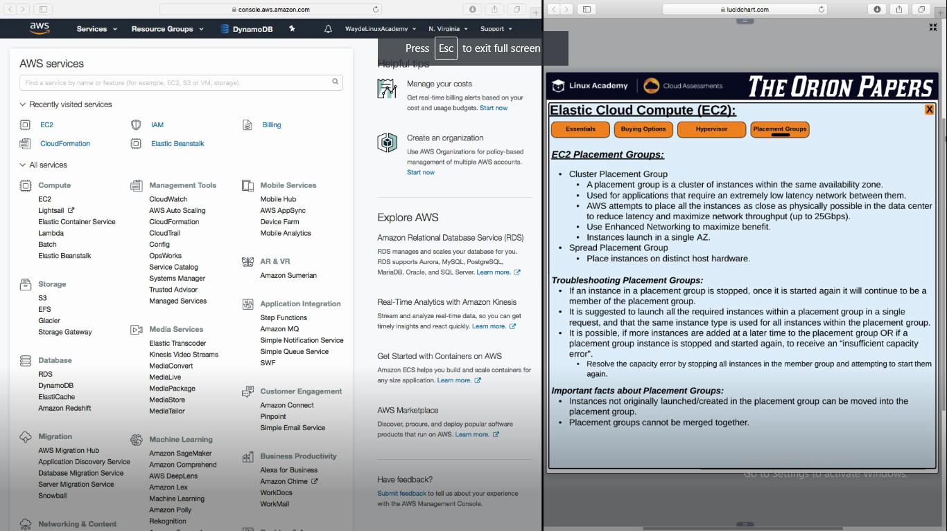

**EC2 Buying options**

